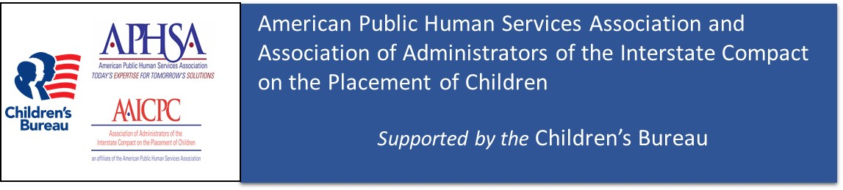H E A L T H C A R E A N D F A M I L Y
Master Document

Interstate Compact on the Placement of Children (ICPC)
Information Data Exchange

Information Exchange Package Document (IEPD)


DATE: February 23, 2016

The National Electronic Interstate Compact Enterprise (NEICE) project is operated by the American Public Health Services Association (APHSA) with the Association of Administrators of the Interstate Compact on the Placement of Children (AAICPC) and is made possible by grant number 90XA0151 from the Children’s Bureau. The contents of this summary are solely the responsibility of APHSA, AAICPC and the participating states, and do not necessarily represent the official views of the Children’s Bureau, ACYF, ACF, or HHS.

Table of Contents
1. Overview 3
2. Definitions 4
3. Background 5
A. Overview 5
B. The ICPC Business Process Flow 6
4. Two Ways to Connect to NEICE 7
5. The IEPD and NEICE 8
6. List of IEPD Artifacts 9
1. Exchange Files 9
2. Instance Documents 9
3. Master Documentation Files 9
4. Other Documentation 9
5. Catalog Files 9
7. NEICE Project Team 10

Overview
The National Electronic Interstate Compact Exchange (NEICE) is an electronic system for processing the placement of children across state jurisdictions as governed by the Interstate Compact on the Placement of Children (ICPC). This document provides guidance to state child welfare agencies on the technical steps needed to join the NEICE system using National Information Exchange Model (NIEM) standards, as outlined in the accompanying Information Exchange Package Document (IEPD) information. NIEM standards allow states to translate their data into a common language that can be understood by other data systems.

NEICE is a collaborative project of the Association of Administrators of the Interstate Compact for the Placement of Children (AAICPC) and the American Public Human Services Association (APHSA), and is supported through a cooperative agreement with the Children’s Bureau, in the Administration for Children and Families (ACF), Administration on Children, Youth and Families (ACYF), U.S. Department of Health and Human Services.

The purpose of this document is to provide:
- A high level description of the Interstate Compact for the Placement of Children (ICPC) across state lines,
- Background information on the National Electronic Interstate Compact Enterprise (NEICE) project, and
- The technical methodology by which the ICPC case information will be transferred electronically across state jurisdictions between child welfare agencies.

NEICE is designed to be a flexible information exchange, allowing states to select one of several technical options for connecting to the national system. Although there may be small modifications required to accommodate the unique structure of each state child welfare agency at the local level, the platform will work for any state child welfare agency.

Participating states pay an annual service fee ($25,000 as of December 2015) to access the NEICE system. This fee covers maintenance, server space, and administrative costs to keep NEICE operational 24/7, as well as ongoing enhancements to the system. For more information about the NEICE project, please visit the NEICE website at http://www.aphsa.org/content/AAICPC/en/actions/NEICE.html.

Definitions
This sub section defines the terms that are used throughout this document.
Child: A person, who by reason of minority, is legally subject to parental guardianship or similar control.
ICPC: Interstate Compact on the Placement of Children governs the placement of children across state lines for reunification, adoption or foster care.
ICPC Case Data: An organized record concerning an individual, their family and environment that includes social, medical, psychological and educational history and any other additional information that may be useful in determining appropriate placement.
NEICE Case Management System – web-based case management system for exchanging ICPC child and placement resource information, as well as placement recommendations across state lines.
NEICE Clearinghouse – secure, cloud-based electronic exchange platform that allows one state’s child welfare information system to send and receive ICPC data and documents to another state’s child welfare information system.Placement: The arrangement for the care of a child in a family free or boarding home or in a child-caring agency or institution but does not include any institution caring for the mentally ill, mentally defective or epileptic or any institution primarily educational in character, and any hospital or other medical facility.
Placement Resource: The person(s) or facility with whom the child has been or may be placed by a parent or legal custodian; or, placed by the court of jurisdiction in the sending state; or, for whom placement is sought in the receiving state.
Receiving Agency/State: The state to which a child is sent, brought or caused to be sent or brought, whether by public authorities or private persons or agencies, and whether for placement with state or local public authorities or for placement with private agencies or persons
Sending Agency/State: The state where the sending agency is located, or the state in which the court holds exclusive jurisdiction over a child, which causes, permits or enables the child to be sent to another state.

Background

Overview
The National Electronic Interstate Compact Enterprise (NEICE) is an information technology solution that supports the administration of the Interstate Compact on the Placement of Children (ICPC) by exchanging data and documents across state jurisdictions electronically. Launched in November 2013 as a pilot project with six states, by using NEICE, states significantly shortened the time it takes to place children across state lines, and saved participating states thousands of dollars in mailing and copying costs. The six jurisdictions involved in the pilot were: the District of Columbia, Florida, Indiana, Nevada, South Carolina, and Wisconsin. WRMA conducted a comprehensive evaluation of the project, including assessing overall impact and efficiency.

In May 2015, the American Public Human Services Association (APHSA) and the Association of Administrators for the Interstate Compact for the Placement of Children (AAICPC) received a grant from the Administration for Children and Families (ACF), Administration on Children, Youth and Families (ACYF), Children's Bureau (CB) to expand NEICE nationwide. NEICE will bring on 12 new states between June 2015 and May 2016, and additional states in 2017 and 2018, with the goal of having all 50 states, D.C. and the U.S. Virgin Islands using the system by the end of the grant in May 2018.

The primary objectives and benefits are:
- Shortened processing time – Faster delivery of case information between the participating states lead to faster processing of children’s cases.
- Potential Reductions in Administrative Costs – Initial reviews have sown that there is potential reductions in Administrative Costs.
- Paper Reduction – Achieves dollar savings in paper, postage, storage, courier, etc. as well as minimizes the staff burden of archiving records and destroying archived records according to State regulations.
- Error Reduction – Minimize double entry of any information. Single entry for electronic exchange reduces the opportunity for keystroke error and thus decreases the time spent by child support and judicial/legal agency staff correcting data entry errors.

The ICPC Business Process Flow
Currently state and county child welfare agencies, and in some cases private contracted agencies, process ICPC cases according to the regulations of the ICPC, which requires 39 discrete business steps to completely process a case. The current administration of the ICPC is outdated and paper intensive. Most states are copying and mailing hundreds of pages of sensitive case details and documents back and forth. Further adding to the complexities, each state uses a slightly different method for processing ICPC cases. Figure 1 provides a simplified overview of how ICPC cases are processed between most State Child Welfare agencies. A high level overview of the ICPC is also provided at the website identified below.
http://www.aphsa.org/content/AAICPC/en/resources.html

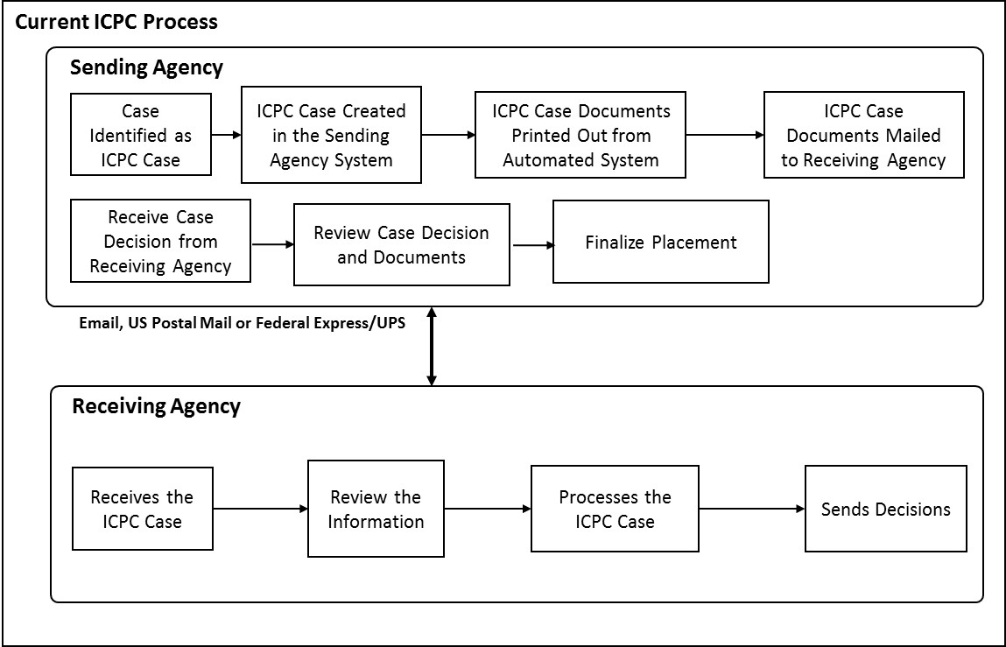
Figure 1, Current Process
As depicted in Figure 1, an ICPC case begins once the case is identified as an ICPC case by the sending agency and a possible placement resource is identified in a different state. An ICPC case file is created in the sending agency’s ICPC/ state child welfare IT system. Once the documents in the file are reviewed and the case file is determined to be complete, these documents are typically printed and sent to the Receiving Agency by US Mail, delivery service (Federal Express, UPS, etc.), fax, or email.

The receiving central ICPC state office reviews this packet to ensure all the required documents are present, processes the request (i.e., performs a home assessment, requests and reviews criminal background checks, etc.), makes a determination on the placement request (i.e., approve or deny), and sends the placement recommendation or determination to the sending agency. There may be a number of interactions between the two agencies, as well as between the various entities involved in the child welfare process within each state, before the final placement decision is ultimately made by the sending agency which originated the request.

The same process is followed in NEICE, however, NEICE employs a secure electronic data exchange to reduce copying and mailing costs, minimize duplicative data entry, and speed up the process of exchanging data across state jurisdictions. To process a case in NEICE, in most states,* the sending state child welfare worker creates the ICPC case and then sends the case electronically to the state ICPC coordinator at the central office to process and check the case. Next the ICPC Coordinator “transmits” the case and documents electronically through NEICE to the Receiving State ICPC office. They review and send the information electronically to the local case worker who completes the home study, and makes a recommendation about the placement, which goes back to the original sending state case worker. All this occurs through an electronic data exchange. This is presented in Figure 2.

*Note: the ICPC process flow is different for decentralized states such as California, Ohio and Colorado, which have a different process for submitting and reviewing ICPC information.

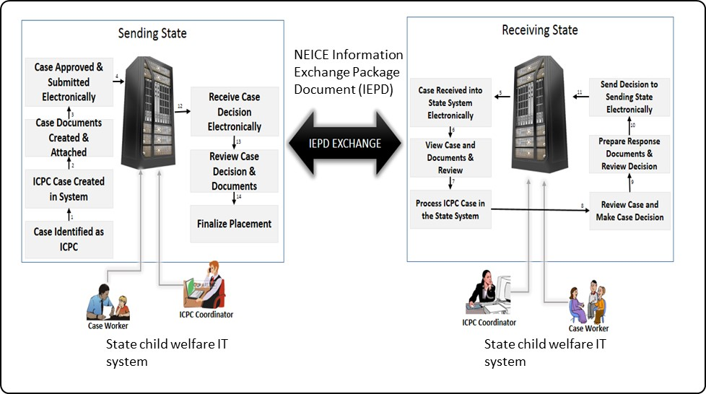
Figure 2, Automated Exchange Process for ICPC Case Data

Two Ways to Connect to NEICE

States can connect to NEICE in two ways, either through an automated interface that exchanges data between their IT system and NEICE Case Management System (which workers access via the web), or by directly connecting their IT system to NEICE Clearinghouse. The Clearinghouse model allows state to process cases from within their state child welfare information system and avoid having to log into a different system to process ICPC cases.

1) NEICE CASE MANAGEMENT SYSTEM VIA THE WEB
The fastest and easiest way to begin using NEICE to manage ICPC cases is through the NEICE web application. After a state’s information has been added to the NEICE system, staff will go to a secure web URL, log in using their unique user id and password, and quickly and easily enter and manage ICPC cases directly in NEICE.

An additional step can help reduce data entry duplication (so that case workers don’t have to enter the same information both in your child welfare information system and again in NEICE). By building a web-based interface, state IT departments can export child welfare and case information (and additional ICPC case information if available) to an FTP folder (either in XML or CSV). This allows state ICPC coordinators or case workers to search a their own state’s child welfare records and pull a child’s case information directly into NEICE to create a NEICE case. Within the web-based NEICE system the case can be quickly created and sent to another state. Through this interface, child and placement resource data can be exported from NEICE into a state’s child welfare information system. Each state only has access to their own caseload data and documents, and information sent to them by other states.

2) NEICE CLEARINGHOUSE
A state may choose to connect their child welfare information system DIRECTLY to the NEICE Clearinghouse, which would act as a data and document exchange. Using the NEICE Clearinghouse will allow state case workers to create and process ICPC cases through tailored screens in a state’s child welfare system. When the case worker submits the ICPC placement request from within the state child welfare information system, the case and placement requests are transported electronically through NEICE as a secure clearinghouse directly to the receiving state.

States that already use their child information system to process ICPC cases will need fewer IT resources to connect their system to the NEICE Clearinghouse. States that do not yet process their ICPC cases within their child welfare information systems may need to invest more front-end IT work to build the necessary screens that allow workers to create and send the ICPC case and placement information directly from a state’s system.

There is no need to provide training to state staff on how to use the NEICE Clearinghouse as it operates “behind the scenes” as a simple data and document exchange (an IT solution). Case workers would use their child welfare information system and manage, build and send ICPC cases from within that system.

The IEPD and NEICE

Regardless of which method a state uses to connect to NEICE, all participating states must translate their data into standardized fields by using this NEICE Information Exchange Package Document, which specifies the manner in which the automated data packets needs to be created.

As depicted in Figure 2, when using NEICE (either model) the case workers/ ICPC coordinators create the ICPC case using the state child welfare IT system and transmit to the Receiving State. This automated data packet will be received by the receiving state child welfare IT system and ingested into their system for processing by the ICPC coordinators/ case workers at the receiving state. Once the placement request is processed, the decision information is then sent back to the sending state for finalization of the placement.

As mentioned above, this NEICE Information Exchange Package Document (IEPD) document describes the manner in which the ICPC case data and the documents need to be formatted for transfer between participant states.

List of IEPD Artifacts
This section lists the artifacts that are present in the NEICE IEPD package.

This IEPD package contains the XML artifacts such as the schema, instance documents, the mapping document, and the domain model. In addition, the IEPD package includes sample 100a and 100b documents (in PDF format) and a screenshot which is the UI used by the case workers in preparing the transmittal of a document to the peer state.

The content of the NEICE IEPD package is provided below.

Exchange Files
- Exchange Schema (neice_exchange.xsd)
- Extension Schema (neice_extension.xsd)
- Extension Schema - Enumerations (neice_codes.xsd)
- Subset Schema (folder titled niem)
- Wantlist (wantlist.xml)

Instance Documents

- The following artifacts are found under the HomeStudyRequest.xml: Sample XML Instance - Home Study Request
- HomeStudyResponse.xml: Sample XML Instance - Home Study Response
- PlacementDecision.xml: Sample XML Instance - Placement Decision
- PlacementDecisionResponse.xml: Sample XML Instance - Placement Decision Response
- FollowupRequest.xml: Sample XML Instance - Followup Request
- FollowupResponse.xml: Sample XML Instance - Followup Response

Master Documentation Files
- NEICE-IEPD-MasterDocument.docx: Master Documentation (this document).

Other Documentation
- Sample 100a Document
- Sample 100b Document
- Transmittal Cover Sheet
- Domain Model
- NIEM Mapping
- Change Log

Catalog Files
- Catalog
- Metadata

NEICE Project Team

The NEICE project team listed below is available to answer any questions related with policy, technical or implementation.

Contact Name | Email | Project Role
Marci Roth | mroth@aphsa.org | NEICE Project Director
Chandra Jonelagadda | chandra@tetruscorp.com | NEICE Technical Advisor
Raghu Govindaraj | raghu@tetruscorp.com | NEICE Delivery Lead

